Pre-Assignment report on NEET paper Analysis

Ans 1: According to the plot obtained below and results, the data seems to be **non-normal** because it’s (mean, variance) is not equal to (0,1) in case of normal distribution and also its mean is not close to variance in order to be called Poisson distribution.

Result:

{'mean': 216.83727248885393, 'median': 165.0, 'variance': 26732.270008105595, 'standard_deviation': 163.50006118685582}

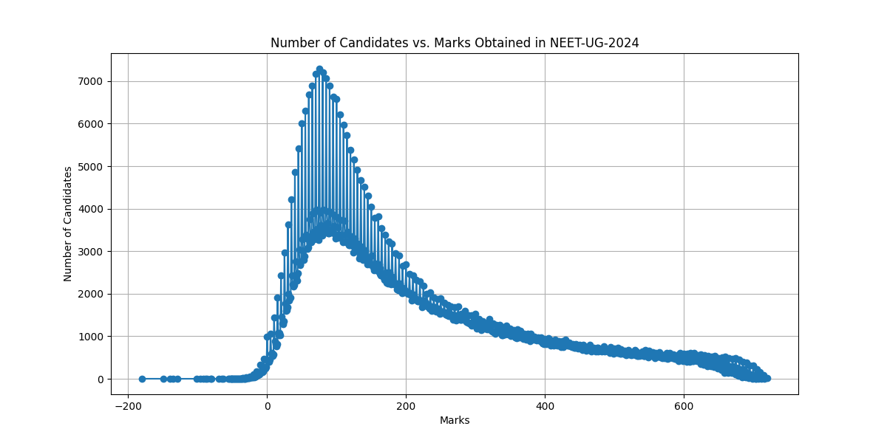

It’s also not guassian distribution, because of the results obtained on using curve fit

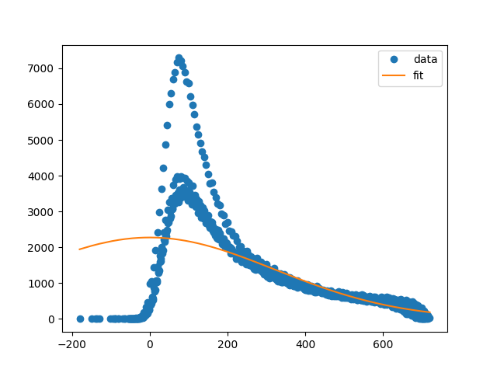

Ans 2: According to the plot shown below, there has been a significant increase in number of students getting higher scores in 2024 in comparison to 2023 and a decrease in number of students getting lower scores. But the distribution seems similar and the mode score bin (having maximum students) is nearly same as well.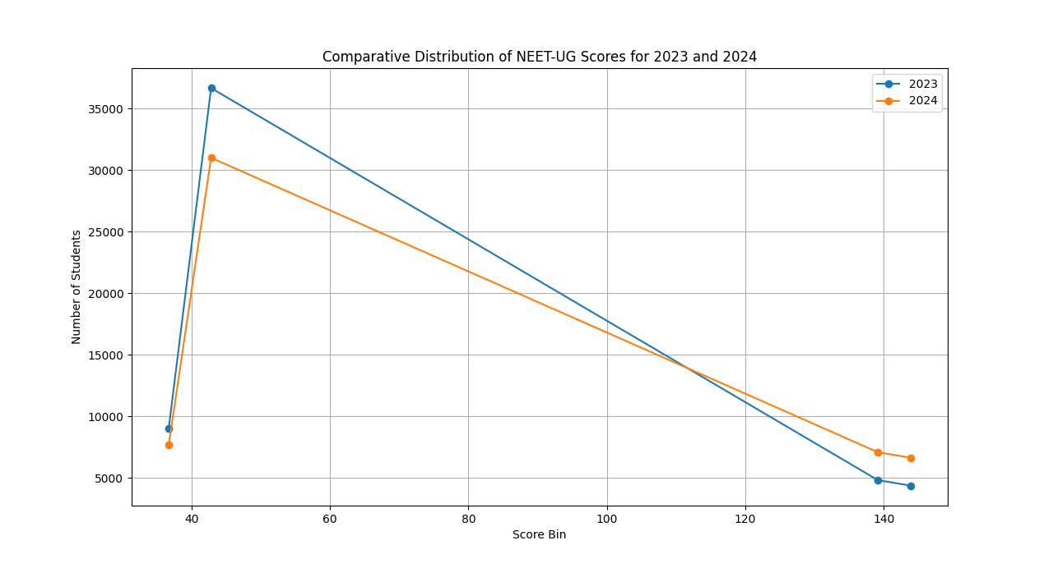

Ans 3: We can get centre specific data (ranking stats (2023/2024) for doubtful regions and mostly focus on the higher marks range (600-720) because we can see in case of 2024, there has been a significant increase in number of students scoring in this range due to which even after getting a very good score, students are not getting good ranks.

If we see in the past 5 years, the number of students scoring higher marks has increased but in case of 2024 we could see a spike in ranks (especially in range of 700-720), which makes the case doubtful.

My remarks:

I think that this is a loop hole by NTA which was there in the past years as well because paper leaks could happen easily as they are printed way before exam dates and transported to local banks through private porters and wealthy people can get them. It came into highlight in 2024 because this time the syllabus was reduced, paper was comparatively easier (according to reports) and 2024 batch was a non-covid batch (both 2 years were offline for them), so we could see a quality difference.